

Ain Shams University

Faculty of Engineering

Third year – Computers and Systems

Submitted by:

|  |  |
| --- | --- |
| 1701577 | نهال ياسر عبد الوهاب |
| 1701571 | نرمين عاطف عبد الكريم |
| 1701111 | ماهينور عمرو احمد |
| 1701595 | نورا نبيل علي |
| 1701636 | هبة عاطف احمد محمد |
| 1600654 | سلمى علي عبد الحليم عوض الله |

# Table of contents

Contents

Table of contents 2

Introduction 3

Target Beneficiaries of the Project 3

Adopted Programming Language 3

System Architecture 4

Application Level Protocol 5

Distributed Database Design 8

Time Plane 16

Testing 17

Nora **Error! Bookmark not defined.**

Nehal **Error! Bookmark not defined.**

Nermeen **Error! Bookmark not defined.**

Heba 24

**Error! Bookmark not defined.**

Salma 26

End User Guige 28

Nora **Error! Bookmark not defined.**

Nehal **Error! Bookmark not defined.**

Nermeen **Error! Bookmark not defined.**

Heba 34

34

Salma **Error! Bookmark not defined.**

Resources needed: 39

Role of Each Member 39

References 40

# Introduction

The goal of this document is to clarify the functionality of our Online Marketplace system and its features to the reader by showing different diagrams that describe our system in details. It shows distributed database diagrams, the system architecture and how to use it.

“Shams Store” is our product name. It a software system to handle main market services like searching, purchasing, selling and sharing items.

The document includes the user interface and showing how the user can deal with the system. It also includes screenshots for our system and results of testing of our project.

# Target Beneficiaries of the Project

Anyone who has enough responsibility and control over their money can use this system easily. Including buyers and sellers.

# Adopted Programming Language

**For the front end:**

HTML, CSS, Bootstrap

**For the back end:**

Asp.net core framework, MVC

# System Architecture

The **Model-View-Controller (MVC)** is an architectural pattern that separates an application into three main logical components: the **model**, the view, and the controller. Each of these components are built to handle specific development aspects of an application. MVC is one of the most frequently used industry-standard web development framework to create scalable and extensible projects.

## MVC Components

Following are the components of MVC

### Model

The Model component corresponds to all the data-related logic that the user works with. This can represent either the data that is being transferred between the View and Controller components or any other business logic-related data. For example, a Customer object will retrieve the customer information from the database, manipulate it and update it data back to the database or use it to render data.

### View

The View component is used for all the UI logic of the application. For example, the Customer view will include all the UI components such as text boxes, dropdowns, etc. that the final user interacts with.

### Controller

Controllers act as an interface between Model and View components to process all the business logic and incoming requests, manipulate data using the Model component and interact with the Views to render the final output. For example, the Customer controller will handle all the interactions and inputs from the Customer View and update the database using the Customer Model. The same controller will be used to view the Customer data.

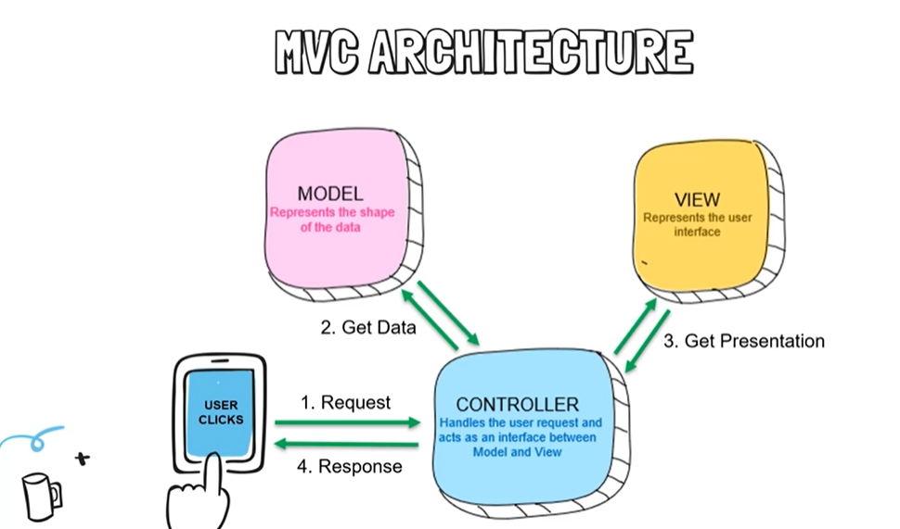

# Application Level Protocol

**Link:** https://www.diagrameditor.com/webapp/?ui=atlas&tr=0&gh=0&gl=0&gapi=0&od=0&db=0&lang=en#Lalp.

**First scenario: Login**

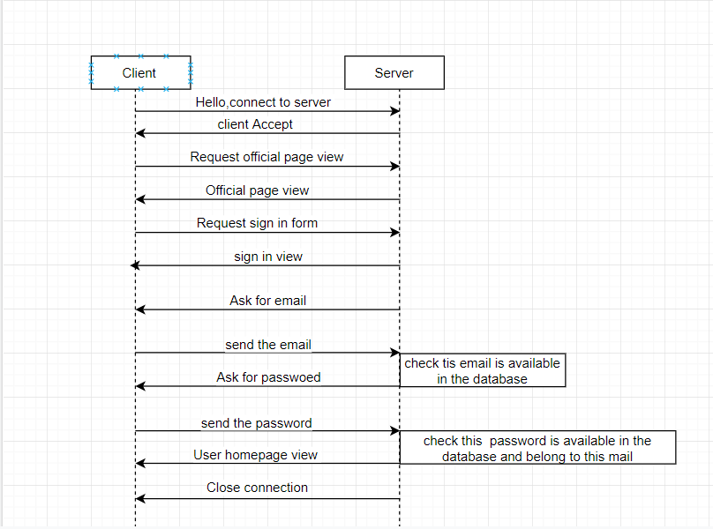

**Second scenario: Add item**

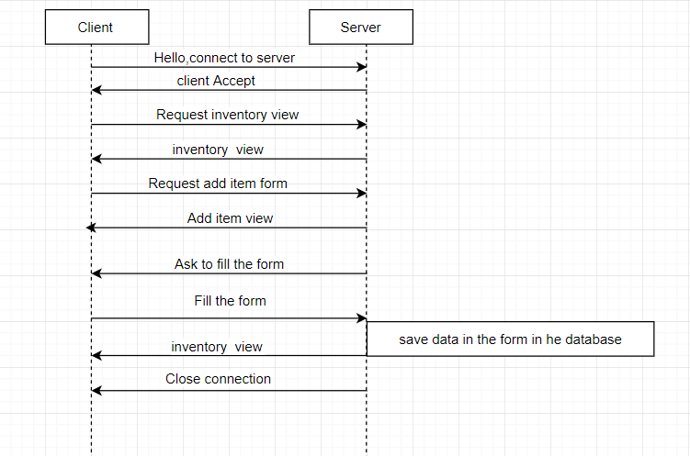

# Distributed Database Design

**Entity Relationship Diagram**

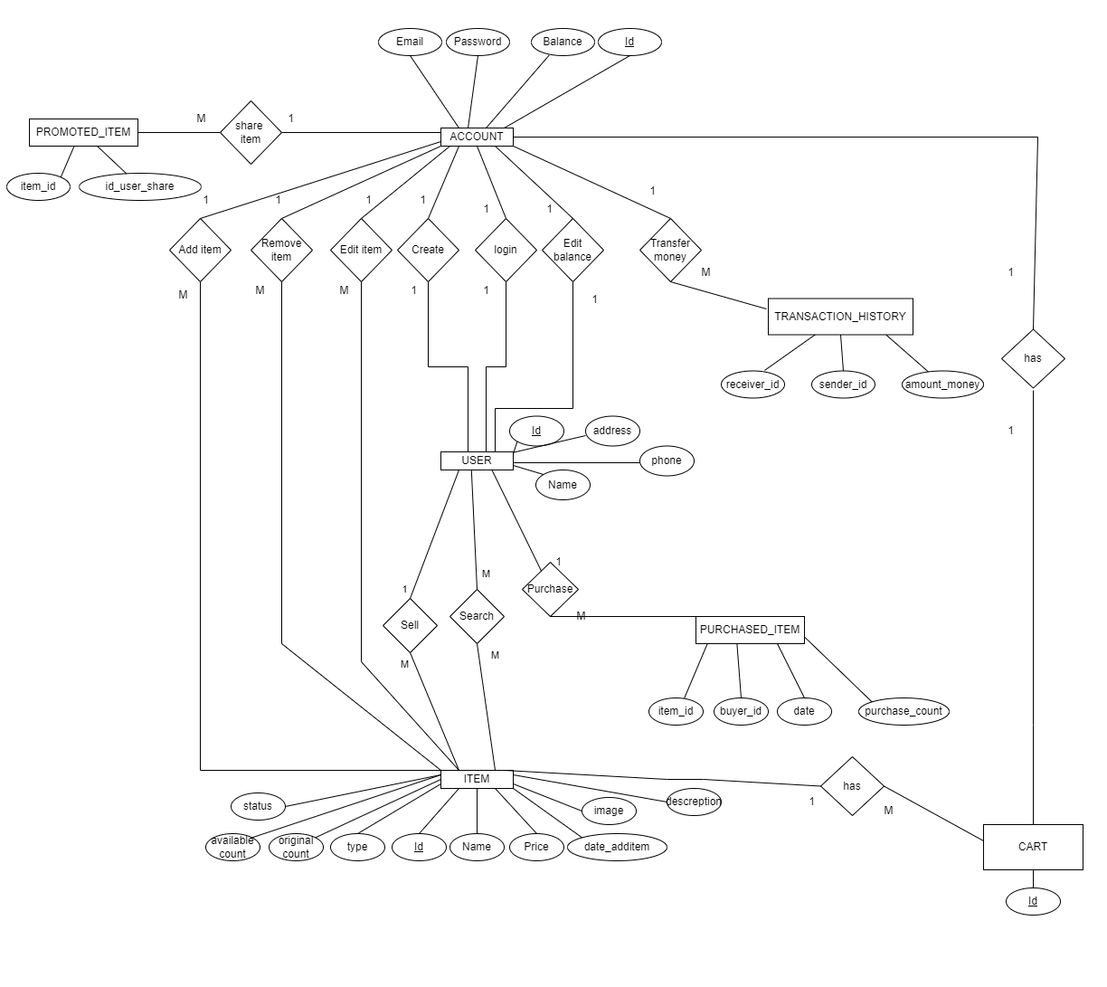

**Database Schema**

**1- Account schema:**

**We used vertical fragmentation in the account schema to separate the data related to the balance and the login data as shown in the following figures:**

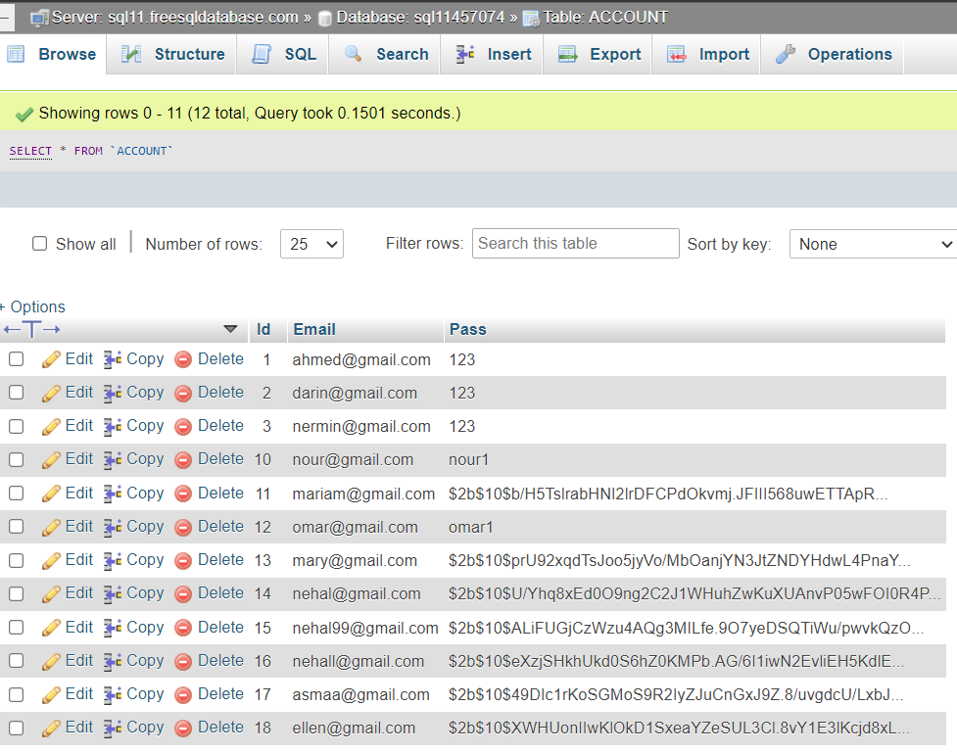

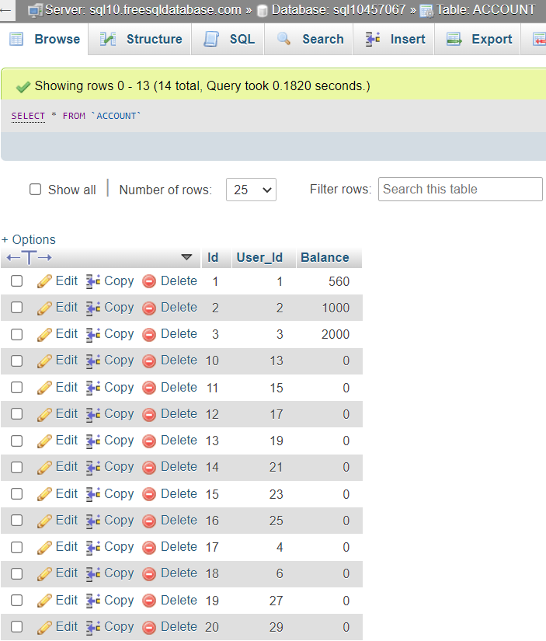

**2- User schema:**

**We used horizontal fragmentation in the user schema as shown in the following figures:**

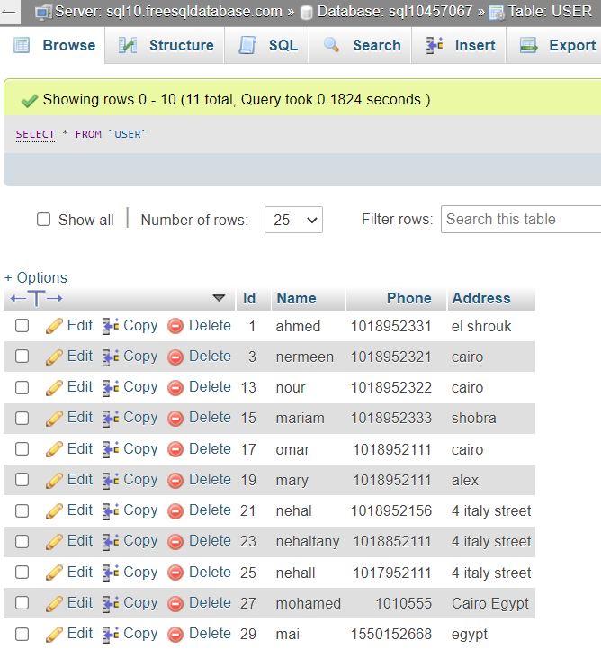

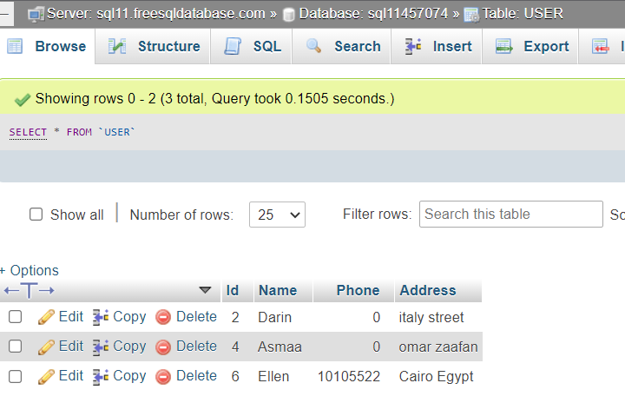

**3- Cart schema:**

**We used horizontal fragmentation in the cart schema as shown in the following figures:**

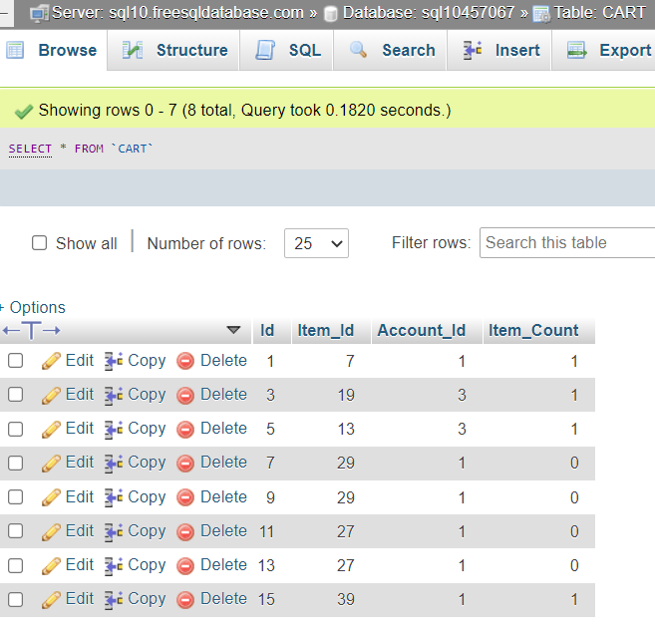

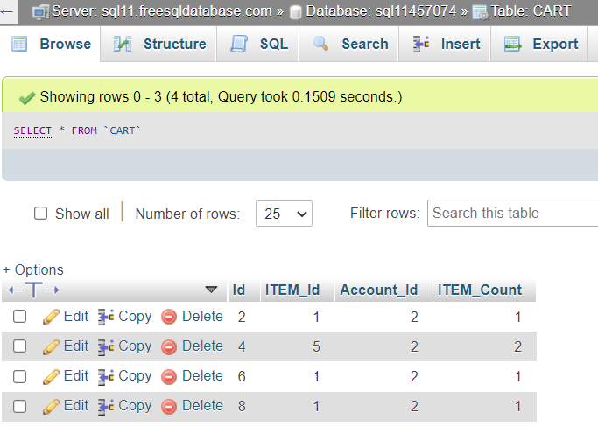

# Time Plane

|  |  |  |
| --- | --- | --- |
| **Task** | **From** | **To** |
| Searching phase | 30/10/2021 | 5/11/2021 |
| Designing the ER diagram | 6/11/2021 | 10/11/2021 |
| Designing the database | 11/11/2021 | 13/11/2021 |
| Designing the website | 14/112021 | 17/112021 |
| Midterm break | 18/11/2021 | 27/11/2021 |
| Learning phase  (to deal with distributed database) | 28/11/2021 | 30/11/2021 |
| Learning phase (ASP.NET) | 28/11/2021 | 30/11/2021 |
| Making online servers and making distributed database tables | 1/12/2021 | 3/12/2021 |
| Making the front end for all the pages in our website | 1/12/2021 | 3/12/2021 |
| Making the functions that can deal with the distributed database | 1/12/2021 | 7/12/2021 |
| Working on our backend of the website | 5/12/2021 | 9/12/2021 |
| Making report and taking screenshots | 8/12/2021 | 10/12/2021 |

# Testing

1-First the official page will open to the user

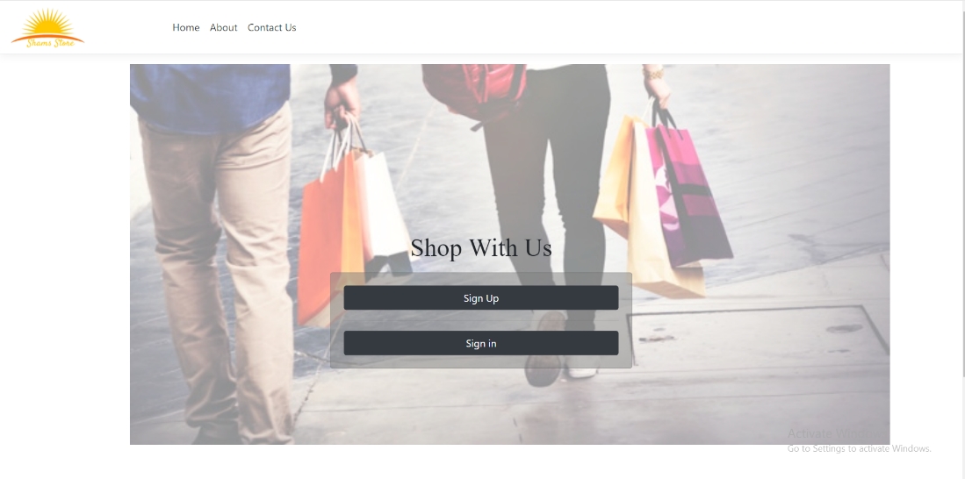

2-The user will click on login button

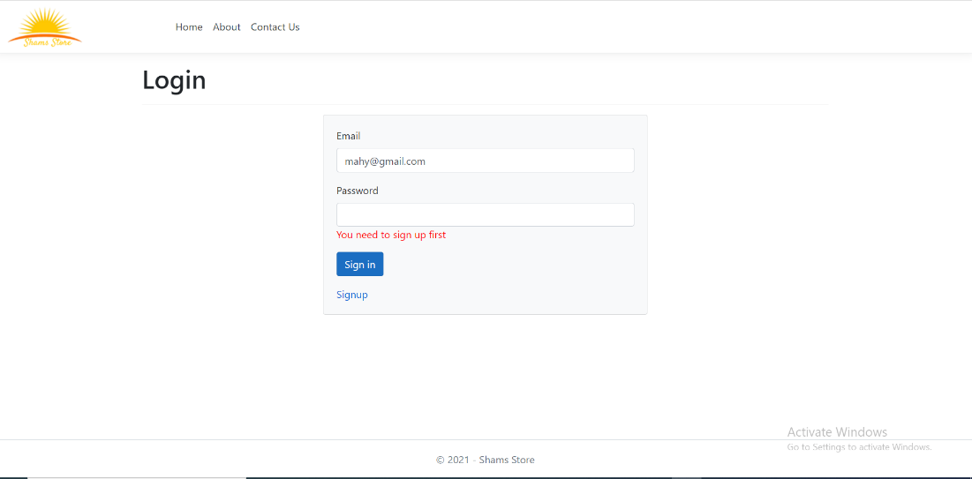

An error will occurs due to that this user did not sign up first

2-The user will click on sign in

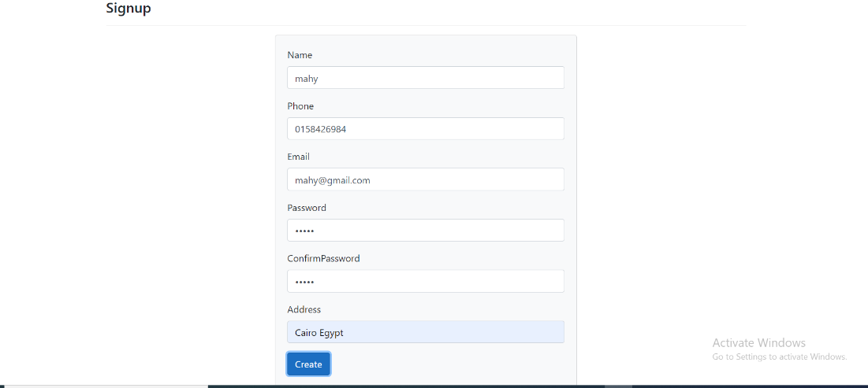

3-After signup the main page will open

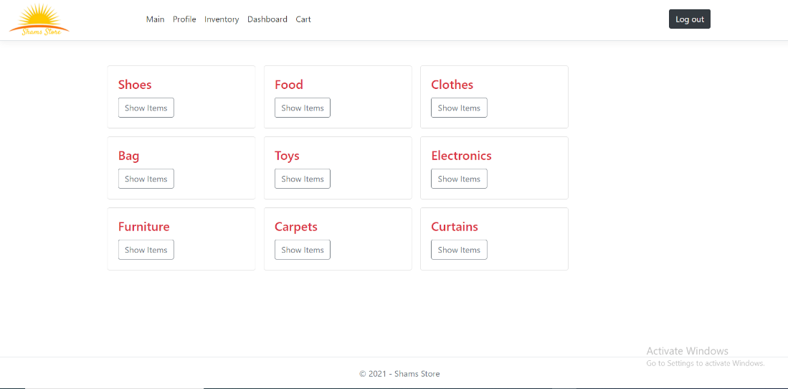

If the user is already sign up and try to sign up again

1-An error will occurs and the user will click on login

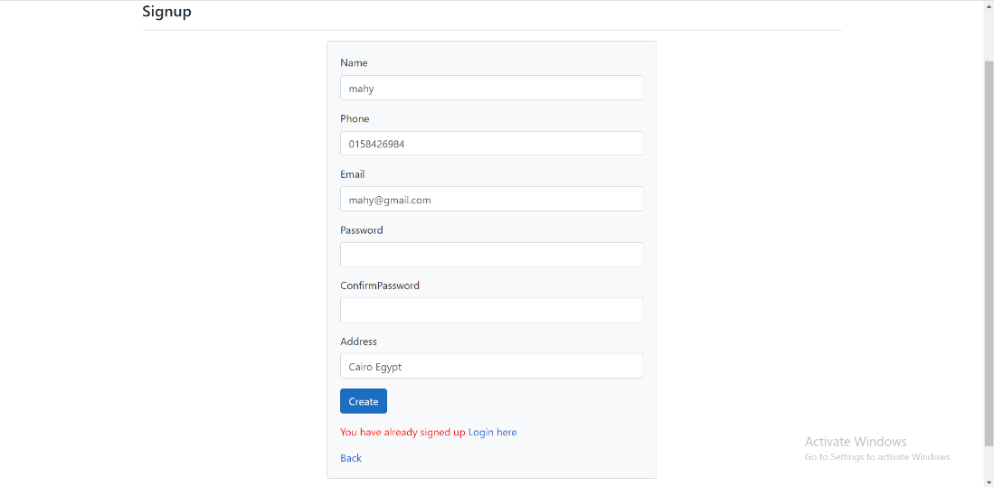

2-the user enters his email and password to login

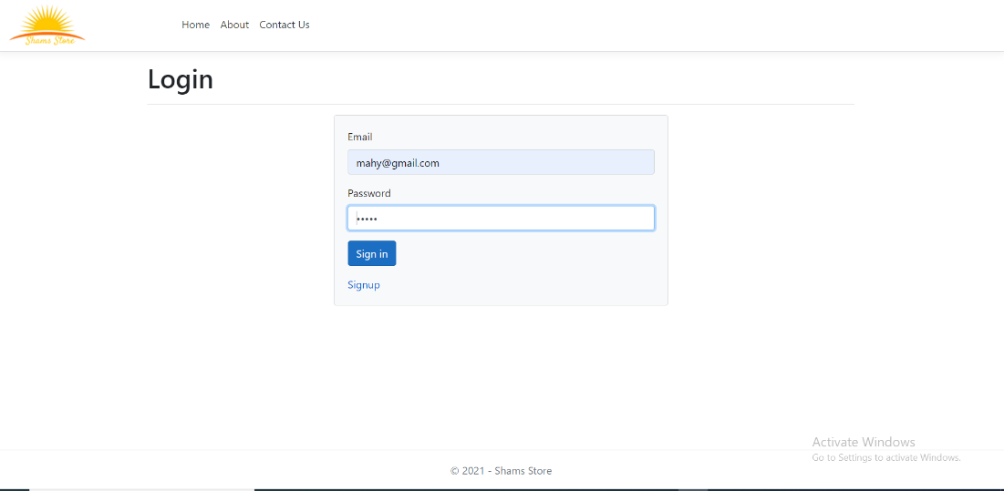

3-the user enters wrong password an error will occurs

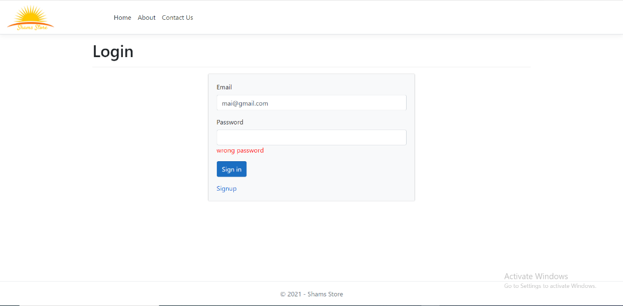

4-the user enters the correct password will be directed to the main page



The Inventory list after the user edited the price of item "heals" and deleted the first item which was Nike

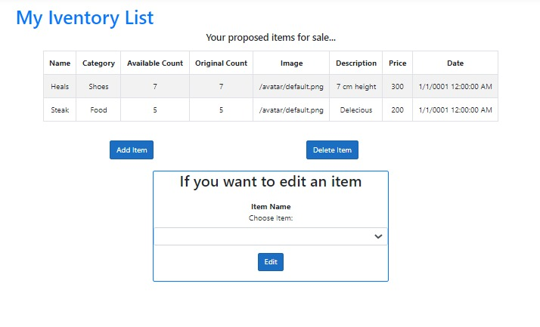

1.owner page

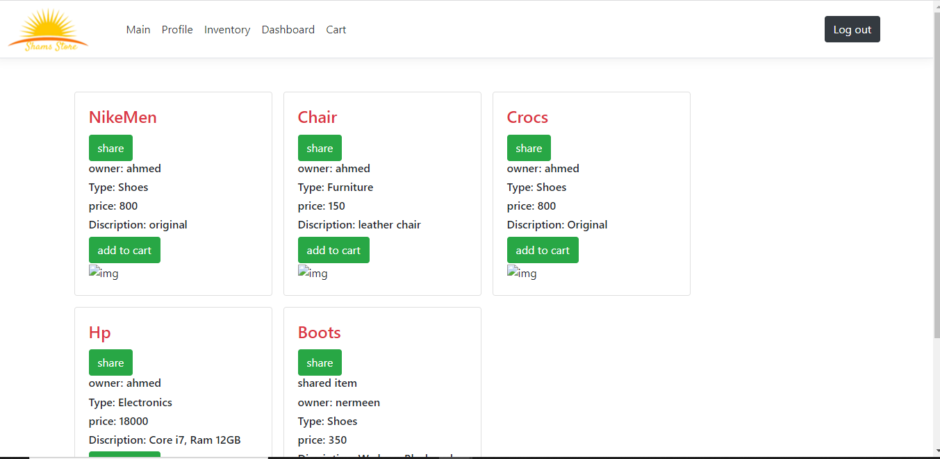

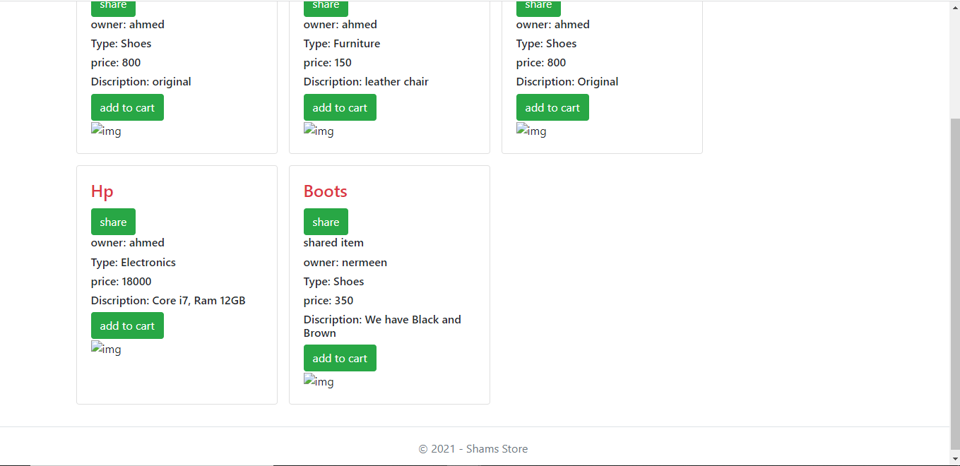

2.Deposit page

## Heba

When clicking Dashboard in the nav bar this is the view to the user from which he can go to sold items page, unsold items page, and purchased items page

Show the sold items that he has sold using the website and total benefit

Show unsold items of the items that the user has added to the website

User shows his purchased items with the total spent money

## Salma

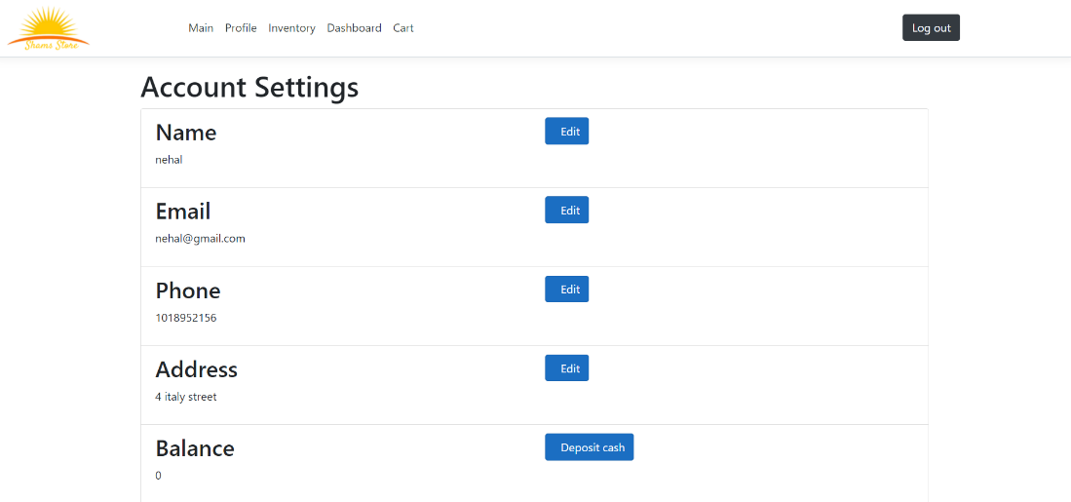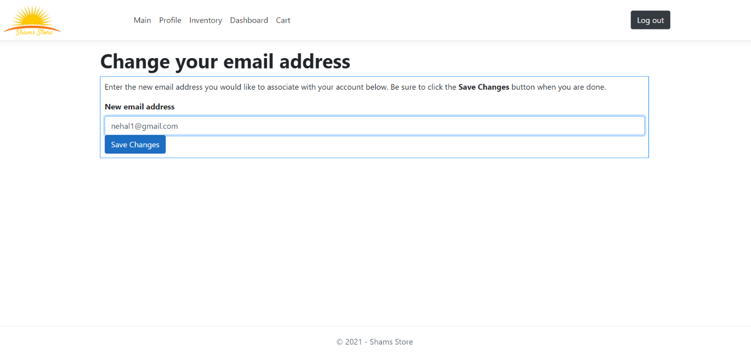

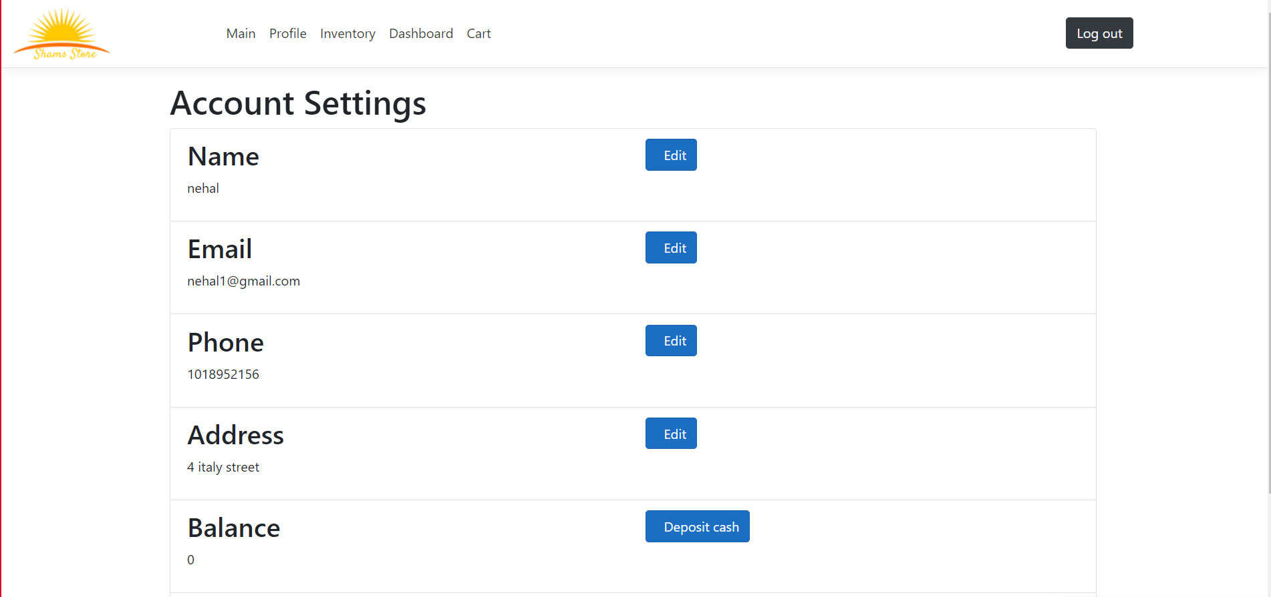

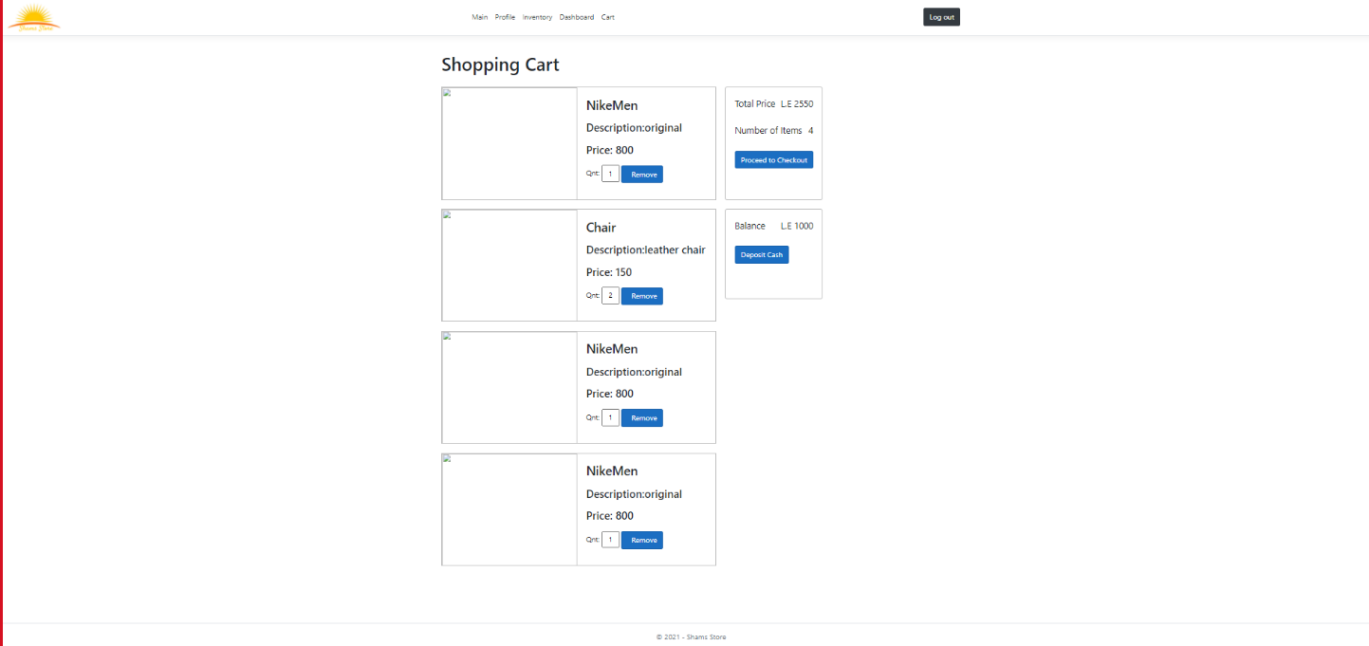

# End User Guide

1-Homepage



2-Click on signup to signup



3-fill this form then click create

4- To login clock login

U,{01cc38b1-dd93-4974-972f-3b92b6c05f8f}{107},10,6.666666666666667

Insert your email and password then click sign in

5-in both cases the main page will open



6-if you want to contact us click on contact us in the navigation bar from this page

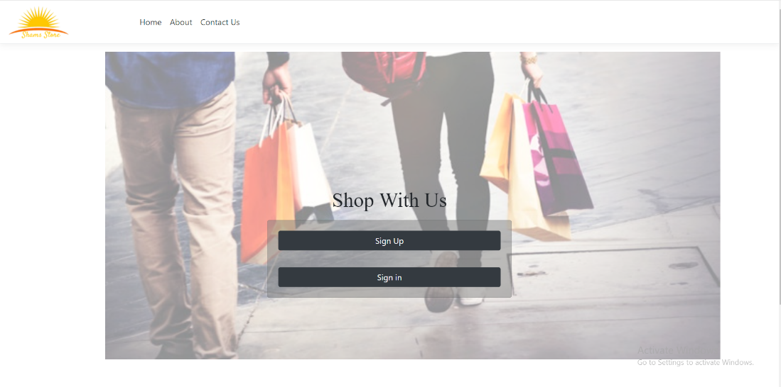

7-fill this form

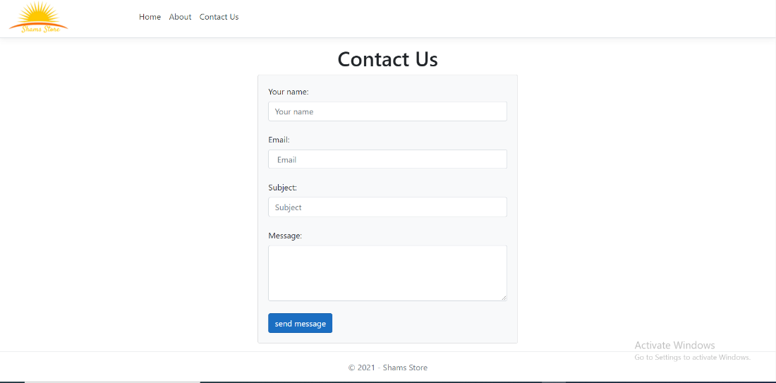

8- if you want to know about us click on about us in the navigation bar from this page

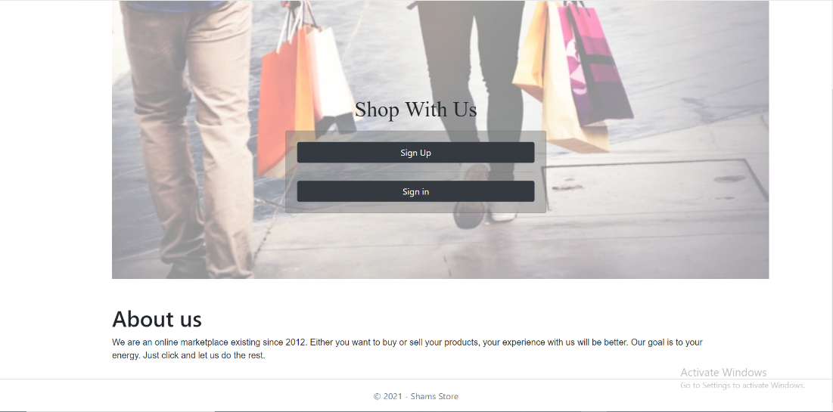

1. Inventory list of a user after he adds 1 item

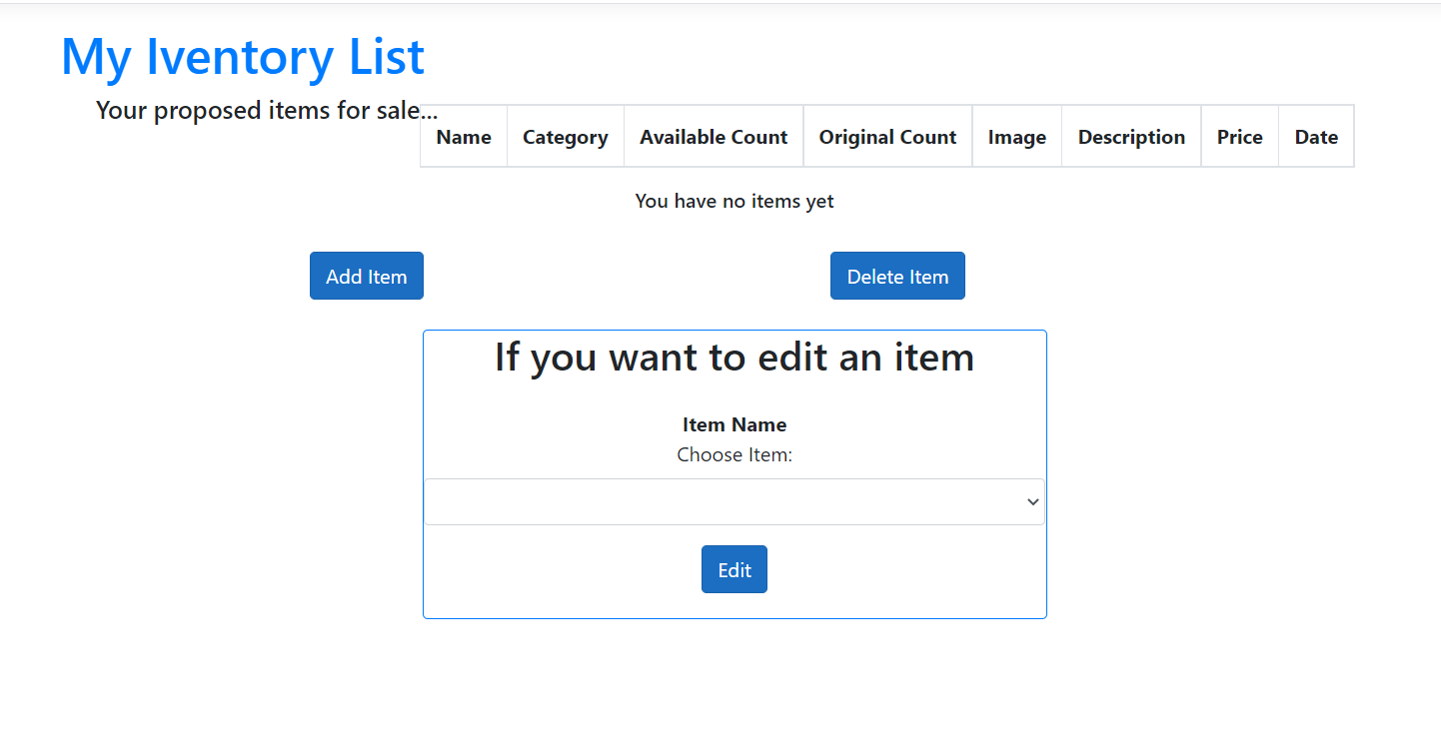

1. When the user clicks on Add Item button in Inventory he gets this form to fill

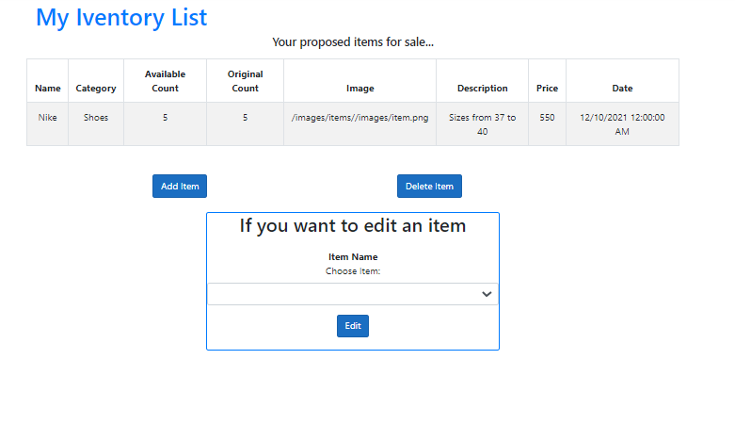

1. When the user clicks on Add Item button in Inventory he gets this form to fill

1.owner page

* In this page we show item for specific owner, which user click on his items.
* So, it you want to share his item in your store you can click on share button.
* So, it you want to add his item in your cart you can click on share add to cart.\

2. Deposit page

* In this page if you need to add money to your account from credit card.
* If you don’t have credit card you can add one by, click on edit credit card to go to profile.
* If you have credit card you can add money by, put number and click deposit.

## Heba

When clicking Dashboard in the nav bar this is the view to the user from which he can go to sold items page, unsold items page, and purchased items page

## 

Show the sold items that he has sold using the website and total benefit

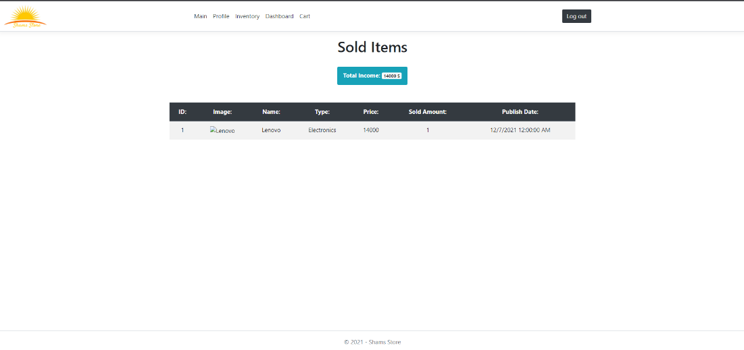

Show unsold items of the items that the user has added to the website

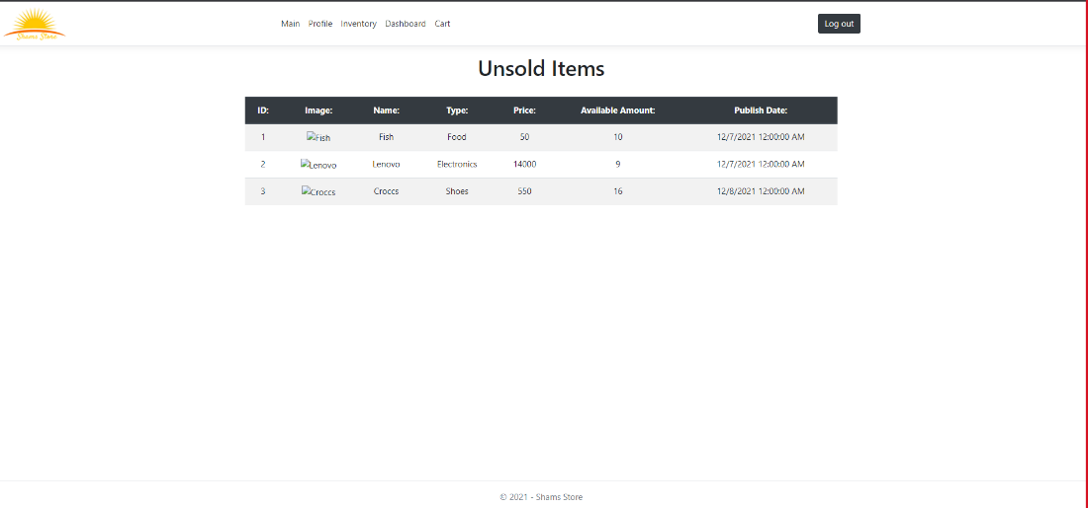

User shows his purchased items with the total spent money



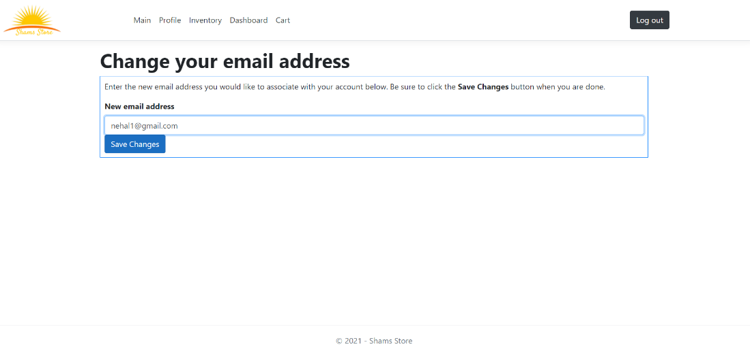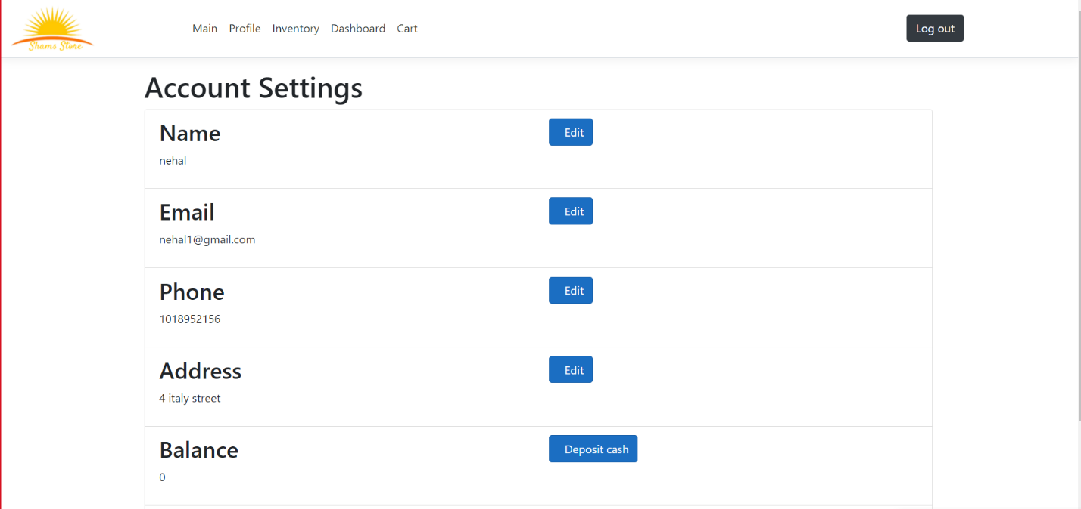

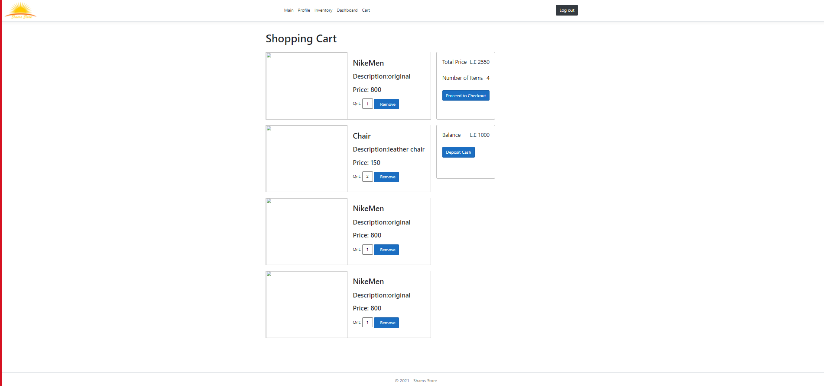

# Resources needed:

We used Asp.Net Core framework and used NuGet packages as :

1. BCrypt.Net-Next
2. Microsoft.EntityFrameworkCore
3. Microsoft.AspNetCore.Session
4. Promelo.EntityFrameworkCore.Mysql

# Role of Each Member

|  |  |
| --- | --- |
| Name | Role |
| Noura Nabil | Login system  Signup system  Alp diagram  Testing  Time plan |
| Nermeen Atef | Create data base ownerp age &deposit page |
| Nehal Yasser Abd El-Wahab | Inventory page, Add item,edit item, Delete item and Main pages |
| Heba Atef | Repositories for controlling the database, dashboard views and item views |
| Mahinour Amr | Home Page, Contact, About, CatItemsPage, Layout, Introduction |
| Salma Ali Abd elhalim Awadallah | Profile,Cart |

# References

ASP.Net documentations